**Customer Dashboard**

1. **Problem Statement:**

* Financial Analysis is a Business/Organation enforcement duty that involves a systematic patterns and trends in Marketing State. Pattern information can help Company deploy resources more effectively and detectives.

**Solution:**

* This solution empowers Customer Engengement Analysis to make informed decisions regarding the Marketing performance of your company. Developed using the latest Teblueau functionality, this solution is easy-to-use and highly customisable to match your company’s branding.
* With our marketing(customer) Dashboards, you can effectively monitor and evaluate relevant marketing KPIs and metrics in a set of interactive and easy-to-use visualisations.

1. **About Dataset:**

* This dataset contains Customer Engegement Analysis reported. In this report, information about Customer Id, Customer Name, Email Opened, Email received, Product ID, Product, Sales value, Email count, etc..

1. **Tableau Sheets:**

* Product VS Count of Customer:

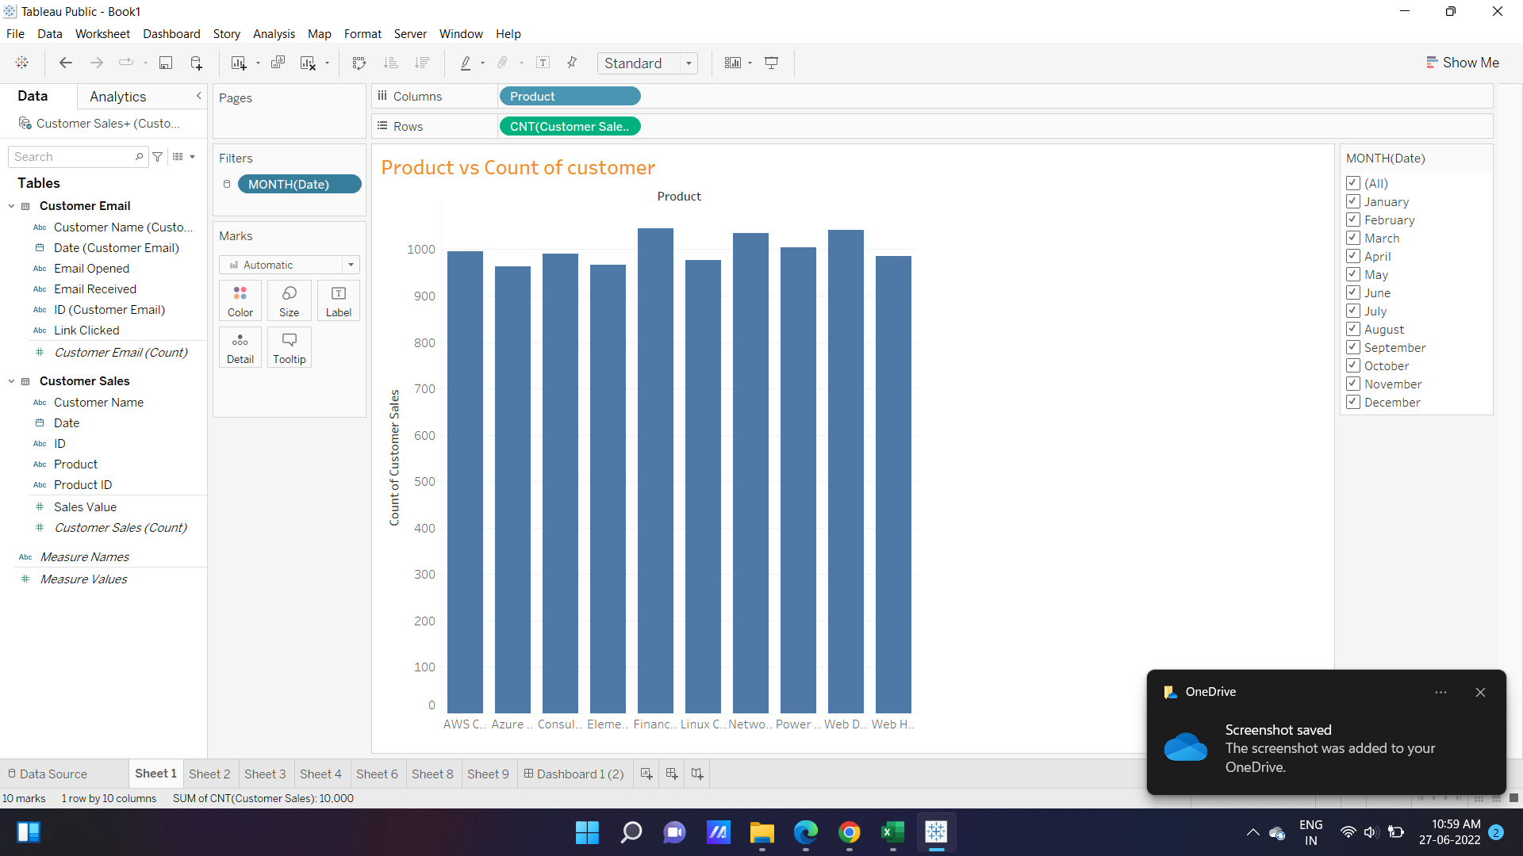

* Customer name and Product ID

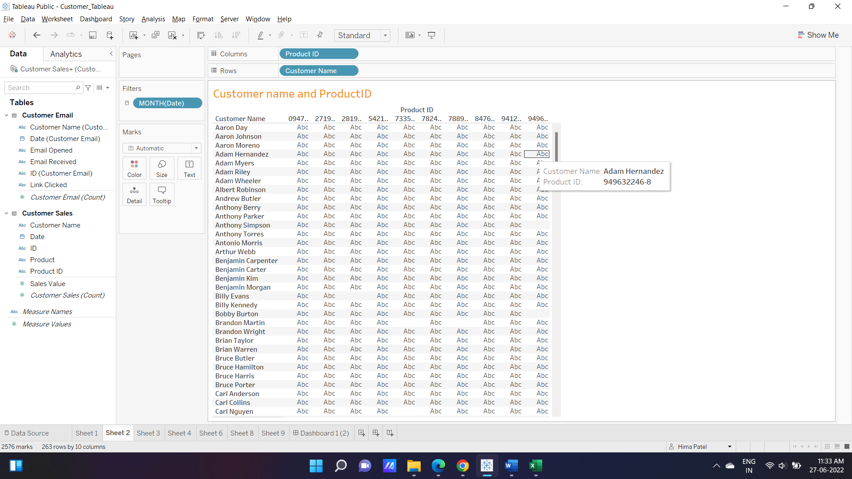

* Sales Value and Product

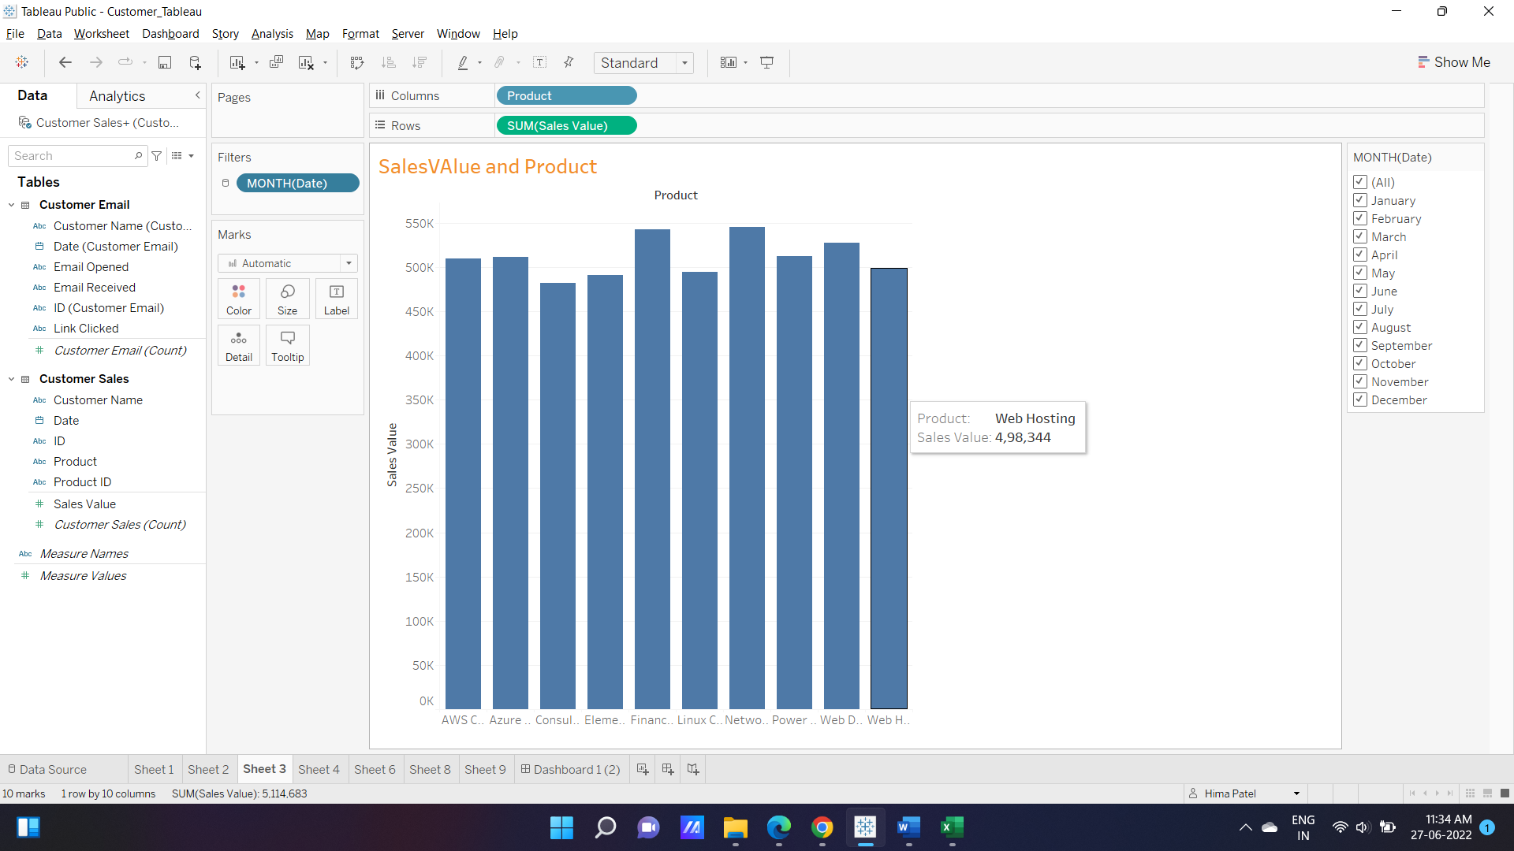

* Count of Customer Sale and ProductID and Year

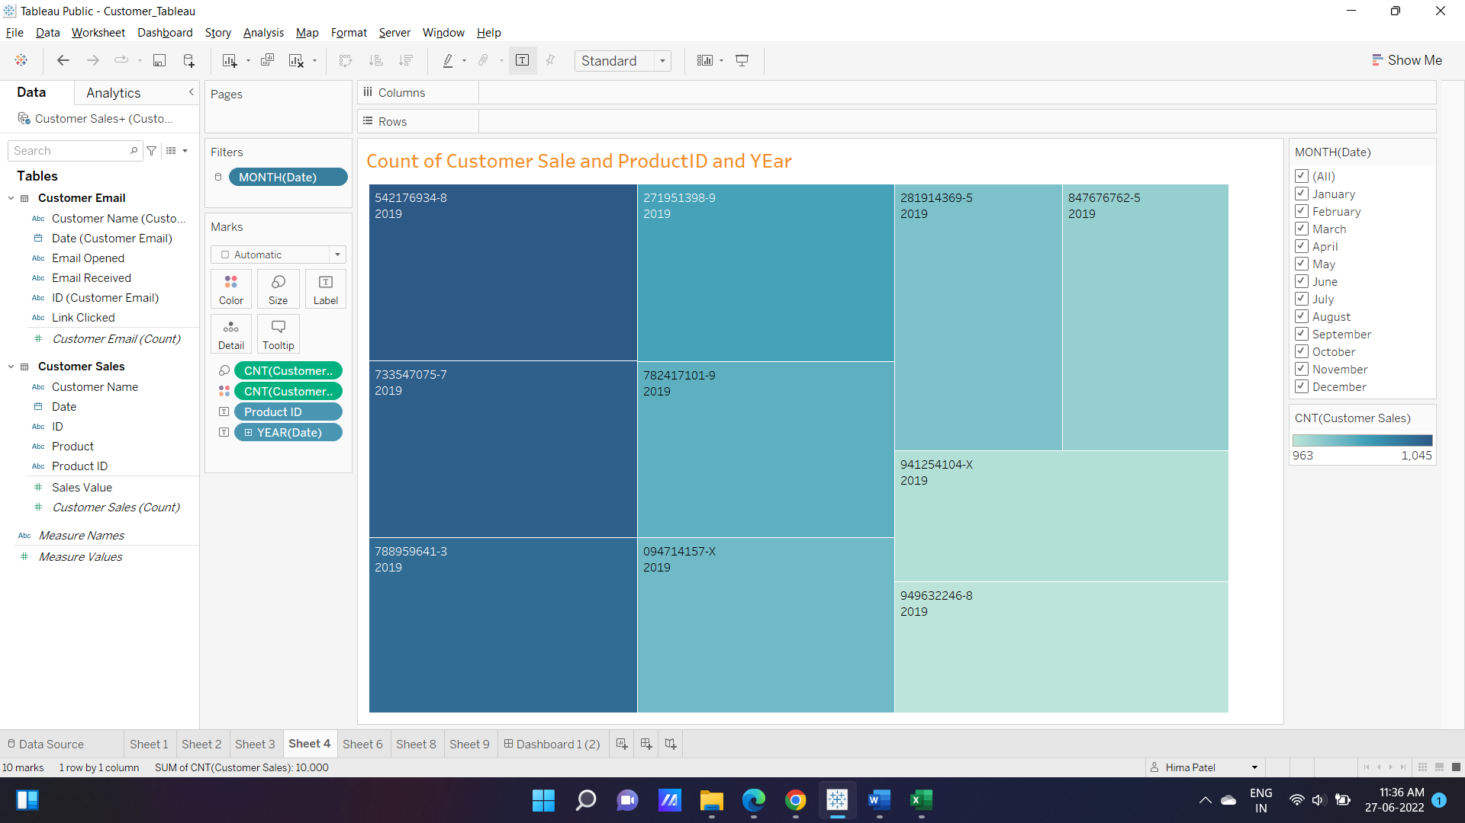

* Product and ProductID

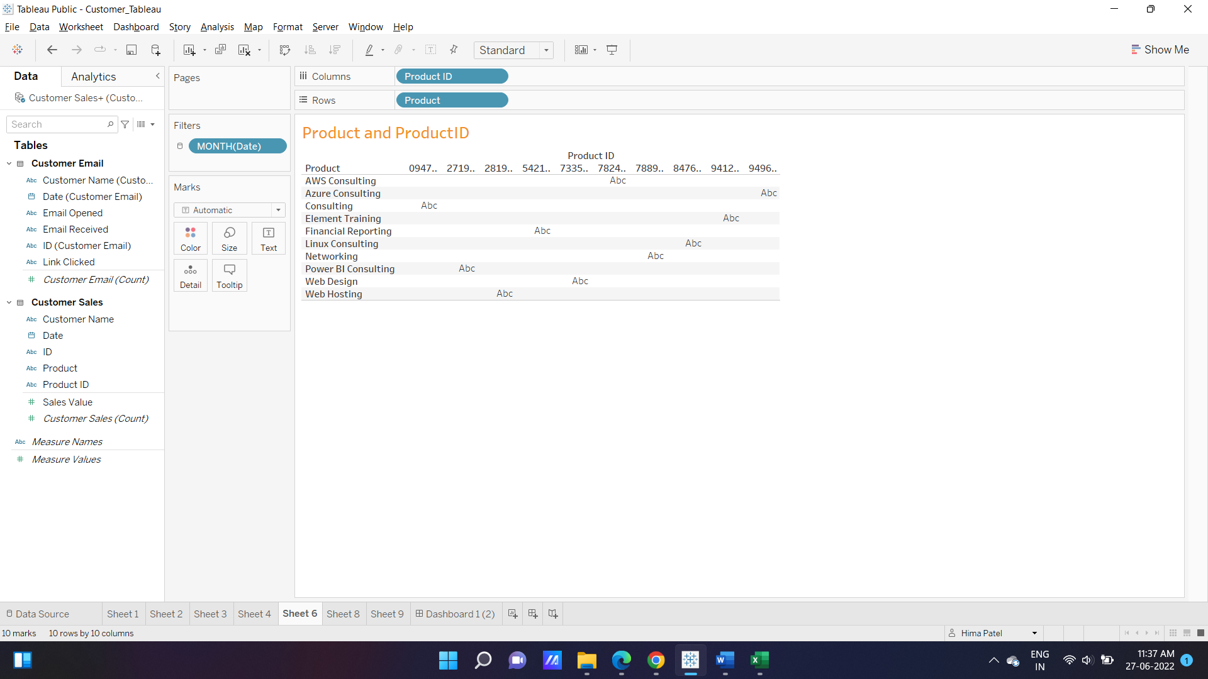

* Sale value vs Product

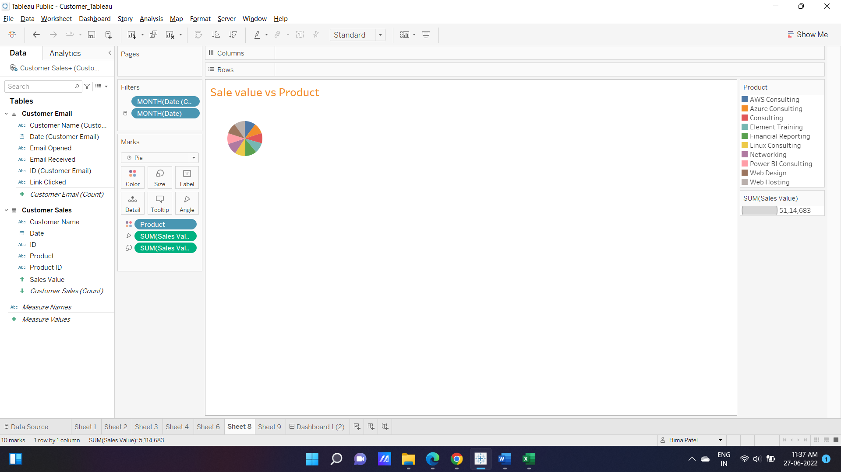

* Count of customer email vs Email Received,Email Opened,Link Clicked

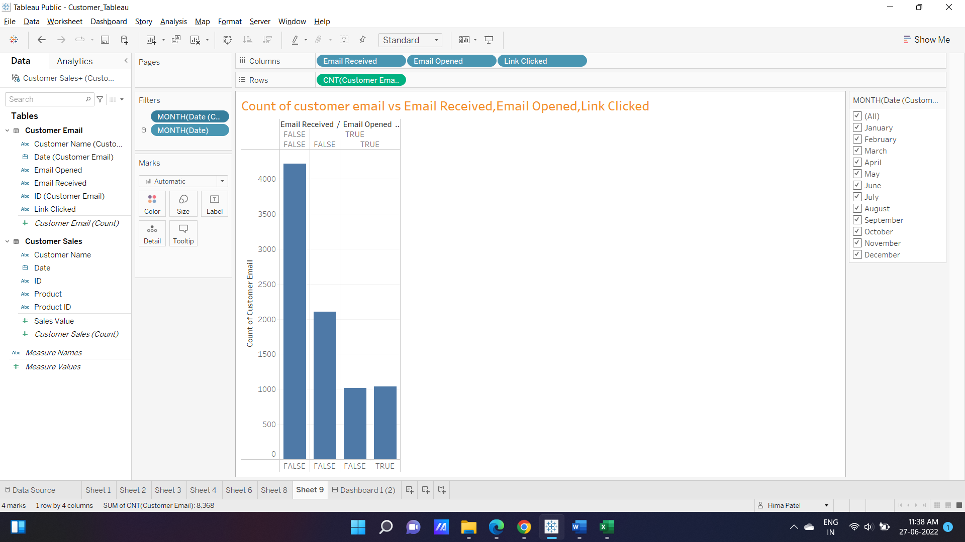

1. **KPI’S:**

In which followings KPIS are present :

1. **Product ID:**

Product identification is **a broad category of labeling that includes functions such as product traceability, brand protection, and various information labels**. With a rapidly changing business environment and constant threats from theft and counterfeit products, product identification labeling is critical.

1. **Product:**

In marketing, a product is **an object, or system, or service made available for consumer use as of the consumer demand**; it is anything that can be offered to a market to satisfy the desire or need of a customer.

1. **Sales Value:**

The amount of money that sth would make if it were to be sold.

1. **Links Clicks:**

Links Clicks is **the count of the number of times your links in ad text, media, or call-to-action have been clicked**. Links can lead to destinations within or outside the social media platform where your ad is published**Gross Margin**

The definition of gross margin is the profitability of a [business](https://learn.financestrategists.com/finance-terms/business/) after subtracting the [cost of goods sold](https://learn.financestrategists.com/finance-terms/cogs/) from the [revenue](https://learn.financestrategists.com/finance-terms/revenue/).

It is a reflection of the amount of money a company retains for every incremental dollar earned.

1. **Email Opened**

Email open rate is **the percentage of subscribers who open a specific email out of your total number of subscribers**. Many people look to their email open rate to determine how successful their email marketing strategy is and, while email open rate is important, no one metric should determine your strategy.

1. **Visualization and Result:**
2. **Dashboard:**

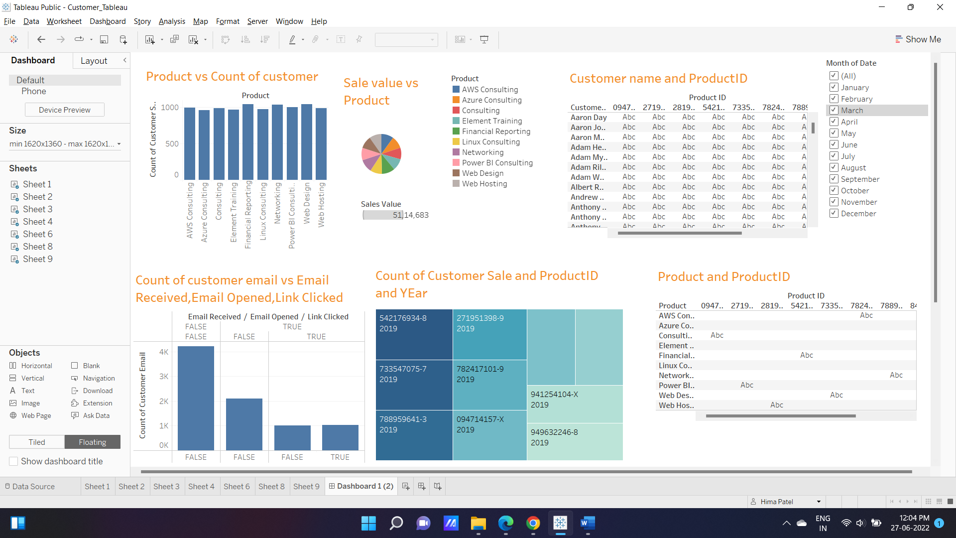

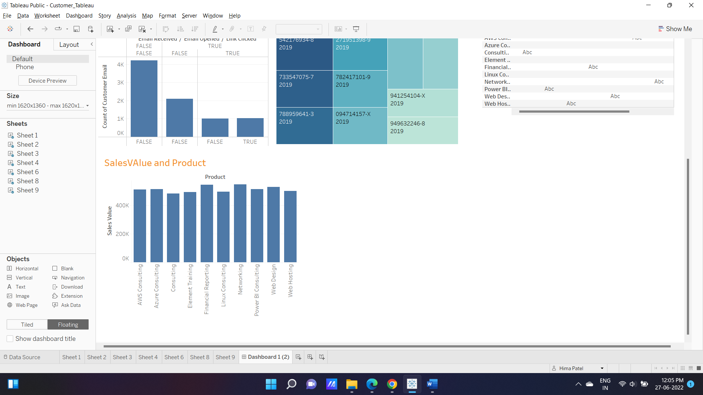

1. **Conclusion:**

Tableau can be the go-to solution for Modern Data-driven Marketers. It allows Marketers to unify data from various Marketing Data Sources such as Social Media, Advertising, Customer journey platforms & more and create a Marketing Single Source of Truth. Marketers can then run intuitive & advanced Marketing Analytics to generate & see insights that matter the most. Its drag-drop Dashboarding allows creating reports in minutes without the hassle of writing code.

1. **Future Work:**

* A Customer operations dashboard in Tabluea is beneficial in rendering key pieces of Costomer data in the graphical or visualized format
* Provides a means of communicating the key Customer metrics of your Customer Sheet and Customer Email across Month, ID, Cost in order to ensure long-term viability and success.
* Presents an effective means of monitoring your assets and liabilities, thus providing a means to evaluate the capital structure of your company.